Appendix 6: New Features in V 3.0 E
During the 3 years version 3.0 has been available, several minor bugs have been fixed and several new features added. Listed below are some of the main new features in Version 3.0 E. Minor bug fixes are not listed, but are available in the more detailed Readme.doc file available from inside the program.

- You can now jump got the Performance Trends website directly from the program under Help at the main screen.
- You can now view the User’s Manual directly from the program under Help at the main screen.
- Program now reads Performance Trends’ new, very affordable Black Box electronic data logger (interface). Black box can read flow pressure, test pressure, pitot tube port velocity, test temp, flow temp, swirl, flow direction and an input from a switch to record data. See Appendix 5.
- Several new Edit options are available. Now you can click on the top of the Lift or L/D column on the main screen to generate valve Lifts or L/Ds based on the settings in the Test Options screen. See details below.
- Using a new comp hardware number for unlocking the program, to hopefully be more stable. NOTE that this version will require a different unlock # than previous versions.
- Added feature to increment test pressure instead of valve lift This is a method used for testing devices without various valve lifts, like mufflers, air cleaners, air meters, turbo components, etc. Pro version only. See details below.
- Added several features to allow program to direct FlowCom to set the Test Pressure for tests which vary test pressure (not valve lift). Three new Preferences allow you to 1) allow varying test pressure, 2) have the program set Test Pressure at each new point, and 3) have the program automatically increment through all test pressures, basically automating the test after you manually record data for the first point. Pro version only. See details below.
- Added several features to allow you to rename, add, delete and copy folders from the Open menu.
- Now allow calibration pressure input for 1020 benches (typically 25 or 50 inches of water). Previously it was assumed 50” for all SF 1020 benches.
- Fixed a bug where the FlowCom’s barometer could be read incorrectly by the program as a small, negative number.
- Added features to check and allow for Com Port #s up to 6.
- Added F5, F6, F8, F9 “hot keys” to the main screen and FlowCom screen so you can navigate easier through many screens:
  - F5 Go to FlowCom or Electronics screen when at main screen.
  - F6 Go to Comments section when at main screen.
  - F8 go down one port, for example from Intake on Cyl #3 to Exhaust on Cyl #2. This can be done at the main screen or from the FlowCom or Electronics screen.
  - F9 go up one port, for example from Intake on Cyl #3 to Exhaust on Cyl #3. This can be done at the main screen or from the FlowCom or Electronics screen.
  - Esc key to close the FlowCom or Electronics screen and return to main screen.
- Now allow up to 50 lines of printed comments. This was previously limited to 20 lines of comments.
- Greatly enhanced the ability of the program to read SuperFlow FlowComs with a wide variety of different computers and different generations of FlowComs.
- Added a Browse button to the network folder option in Preferences menu.
- Added Tabs to preferences screen to better organize preferences.
- Improved print quality of most all screens and printed reports.
- Add preference for using either Head # (original version) or now File Name for the default Graph Title.
- Added Swirl Analysis report to calculated Estimated swirl torque in Tq, oz in and Newton mm. Pro version only.
- Allow Raw Report to be corrected to different Test Pressures.
- Allow Importing of Flow Pro FP and FP3 files, and some Winflow files, files from other types of flow bench programs. Pro version only.
- Added explanation of what Temperature is recorded in a 1020 bench. (It is not air flow temperature unless you have made provisions to record air temperature in your 1020.)
- Program is now 32 bit, which means: It can use long file names.
It should be more compatible with USB printers.
- Program now uses a faster method of reading the FlowCom. This method also proved more reliable on the new, very fast computers.
- Replaced the graph option of Swirl Stab with Swirl (abs) to graph absolute value of swirl. This graphs all swirl numbers as a positive number so you can see RPM, but not direction. Pro version only.
- Corrected a problem where data other than CFM (like swirl) would not always be graphed or reported correctly if the valve lifts were not in order or similar for different ports.
- Correct problem where opening 'Tip' would always show again, even if you selected to not see it again.
- Added Mass Flow calculations to graphs and reports for English units. Pro version only. See details below.
- Added Option in FlowCom screen to ReZero Swirl/Tumble.
- Allowed Foot or Hand Switch to signal to record data. The user must 'double click' the switch in the current version.
- Fixed a bug where the air temperature recorded by a 1020 bench was not being reported correctly in Reports.
- Added a Note Tip that the air temperature recorded by a 1020 bench is "motor box" temperature and not true air temp of the air flow stream.
- Fixed a bug where printouts for head comparison reports were not complete if you requested a comparison of individual cylinders. Pro version only.
- Fixed several things to calculate Velocities, Gs, Piston Pos, FlowCoef, etc for Metric Units.
- Added ability from the File menu (upper left corner of main screen) to Save To or Open From a floppy disk. This makes it easier to copy files from one computer to another.
- Added ability to read Cam Files in Engine Specs. Now you can combine detailed Cam Dr, Cam Pro Plus, S96, Andrews, etc cam files with flow bench data for more detailed analysis. Pro version only. See details below.
- Added several engine analysis graphs like Psuedo Flow Velocity, Piston Velocity, Piston Acceleration and Piston Position. Pro version only. See details below.
- Main and graph screen now fills screen for larger resolution screens like 600x800 and larger.
- Data tables included with graph were not using 'Alternate Names' which you had entered manually. Pro version only.
- Added feature to allow comparison reports between individual cylinders of different heads in the Pro version. In the Reports Options screen, pick one of the Compare Report Types. Then select one of the individual cylinders for Which Cylinder. Then when you pick the test from the library for comparison, you are also asked which cylinder to compare to the cylinder of the first (current) test.
- Fixed bug where Filter feature did not correctly find Test Dates. Pro version only.
- Fixed bug where Filtering Files = On did not allow head and engine files to be displayed in the Open File screen. Pro version only.
- Added ability to allow L/D increments to be graphed'and reported for port velocity measurements. Pro version only.
- Added ability to run JKM style flow bench..
- Fixed bug where arrow keys in Test Options erased Int and Exh port adapters if they were entered by hand.
- Fixed bug where basic version could print Head Details and Engine specs in report printouts.
- Put User Name at top of Report Printouts, moved Perf.Trends (C) to 3rd line.
- Now allow 32 graph lines to be graphed at 1 time, which allows 2 8 cyl heads or 4 4 cyl heads to be graphed at once.
- When Entering CFM Directly, the Test Pres Column has been eliminated. The test pressure for the CFM data is now set as the Test Pressure in the Test Options menu. This change eliminates a possible problem when Test Options Test Pres does not match Test Pres in the Data Grid column.
- Fixed a problem in that not all the CFM data was being requested when you printed a Blank Worksheet.
- Added a Preference to not require a Head # for a New Test. Pro version only.
- Now prints cursor line on graphs when printed.
- Added a Preference to hide barometer in FlowCom screen.
- Added 9 new report options for Pro version, mostly either asking for Int only or Exh only, and new Cyl-Cyl Comparison with cylinder CFM averages included. Pro version only. See details below.
- Added option to 'Hide' individual graph lines by right clicking on their name in the Legend on the right side of the graph. Pro version only. See details below.
- Added new button in Preferences called 'Set Graph Colors' where you can manually set the colors of individual graph lines.
- Program now reads some types of WinFlow files (mostly SF 600). Just 'click on' them (either the .PWD, .DAT or
.FTD files) in the 'Open Test File' screen and follow the program directions. Pro version only.
- Added a Preference to disable valve spring specs from being automatically updated (calculated) from other valve spring inputs. Pro version only.
- Fixed bug where Head # was not always updated after being changed in the Head Specs menu. Pro version only.

Complete List of Types of Reports, Many Are New

Int & Exh Raw Flow Data | Int & Exh Cyl-Cyl Comparisn | Int & Exh Calculated Data
Int & Exh Other Calc Data | Eng. Performance Estimate | Meas Int & Exh VelData
Compare Heads - CrCFM @Lift | Compare Heads - VArea @Lift | Compare Heads - FArea @Lift
Compare Heads – FlCf @ Lift | Compare Heads - VVel @ Lift | Compare Heads - PVel @ Lift
Compare Heads - CrCFM @ L/D | Compare Heads - VArea @ L/D | Compare Heads - FArea @ L/D
Compare Heads – FlCf @ L/D | Compare Heads - VVel @ L/D | Compare Heads - PVel @ L/D
Int Raw Flow Data | Int Cyl-Cyl Comparisn | Int Calculated Data
Int Other Calc Data | Exh Raw Flow Data | Exh Cyl-Cyl Comparisn
Exh Calculated Data | Exh Other Calc Data | Int & Exh Cyl-Cyl Comp +Avg
Int Mass Flow | Exh Mass Flow | Int & Exh Mass Flow
Calc. Int Swirl Analysis

Complete List of Types of Graphs, Many Are New

Corr Int & Exh CFM | Corr Int CFM | Corr Exh CFM
Calc Int Velocities | Calc Exh Velocities | Intake Swirl
Int Swirl (abs) | Intake Tumble | Int Tumble Stab
Int & Exh Flow Coef | Int Flow Coef | Exh Flow Coef
% Exh/Int | Int Stablty | Exh Stablty
Int & Exh Stablty | Int & Exh Flow+Valve Area | Int Flow + Valve Area
Exh Flow + Valve Area | Int & Exh Flow Area+VlvLift | Int Flow Area + Valve Lift
Exh Flow Area + Valve Lift | Overlap Flow + Valve Area | Overlap Flow + Valve Lift
Meas Int Vel (port map) | Meas Exh Vel (port map) | Psuedo Flow Velocity,ft/sec
Psuedo Flow Velocity, Mach# | Piston Velocity, ft/sec | Piston Velocity, ft/min
Piston Acceleration, Gs | Piston Depth from TDC, in | Int Mass Flow Lb/Min
Int STP Mass Flow Lb/Min | Exh Mass Flow Lb/Min | Exh STP Mass Flow Lb/Min
Int & Exh Mass Flow Lb/Min | Int & Exh STP MsFlw Lb/Min | Int Mass Flow Gm/sec
Int STP Mass Flow Gm/sec | Exh Mass Flow Gm/sec | Exh STP Mass Flow Gm/sec
Int & Exh Mass Flow Gm/sec | Int & Exh STP MsFlw Gm/sec

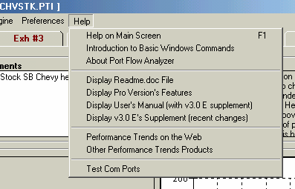
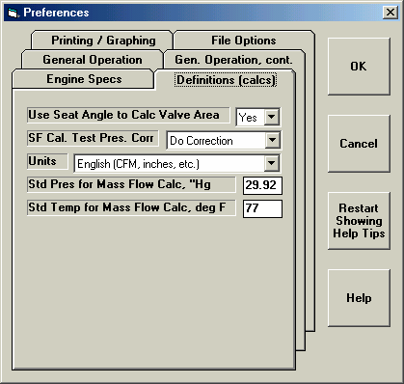
Figure A11 New Help Options and Preference Menu
New “tabbed” layout of Preferences.
Note inputs for Mass Flow calculations.
Many new Help Options
Click on Preference for Preference menu to right
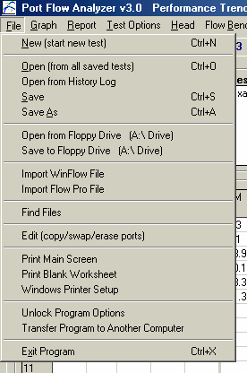
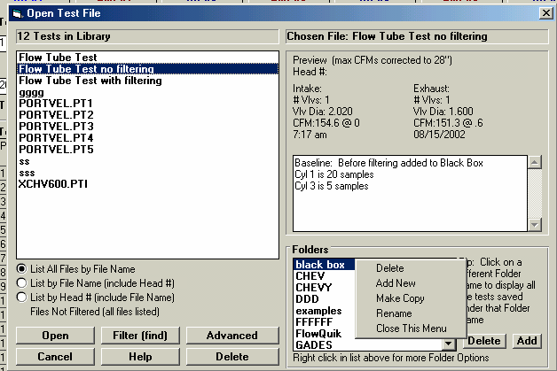
Figure A.12 New File Commands

Note larger Open Test File screen to accommodate longer file names both for tests and folders.
Several new Open, Find, Import, Edit, Find and Save options.
Many new Edit options for folders available by right clicking in Folders List. Note: You must highlight the folder you want to work with first, then right click.

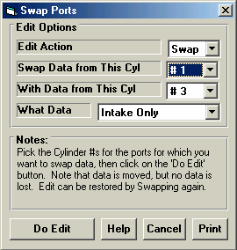
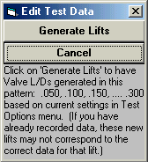
Figure A13 Edit Options
Click on the top of the Lift or L/D column (or Set Pres if you are varying test pressure) for this new Edit option
Click on File at top, left of main screen, then Edit for this menu of options to appear.

Hot Keys for Data Recording (see figure A14 below):
  - F5 Go to FlowCom or Electronics screen when at main screen.
  - F6 Go to Comments section when at main screen.
  - F8 go down one port, for example from Intake on Cyl #3 to Exhaust on Cyl #2. This can be done at the main screen or from the FlowCom or Electronics screen.
  - F9 go up one port, for example from Intake on Cyl #3 to Exhaust on Cyl #3. This can be done at the main screen or from the FlowCom or Electronics screen.
  - Esc key to close the FlowCom or Electronics screen and return to main screen.
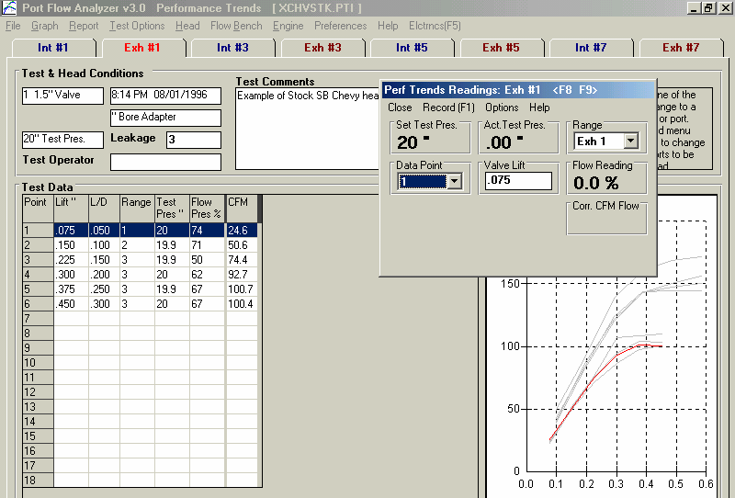
Figure A14 Using “Hot Keys” to Navigate Through Data Recording Screen
F6 at the main screen puts the cursor in the comments section.
Esc key closes this data recording screen.
F8 and F9 step forward or back between the different ports without having to leave the FlowCom or Electronics screen.
F5 from the main screen brings up the FlowCom or Electronics data recording screen.
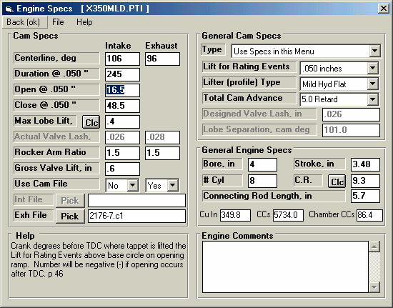
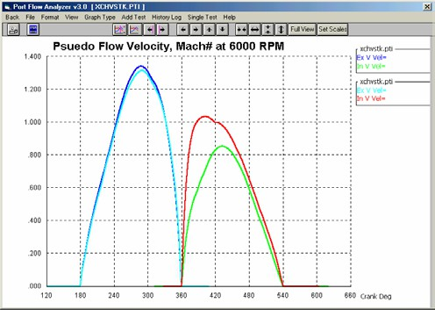
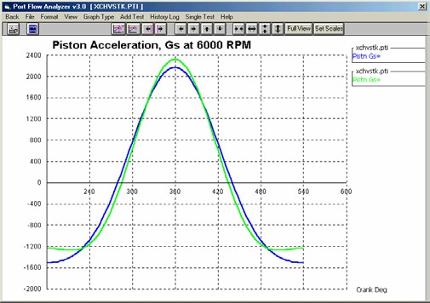
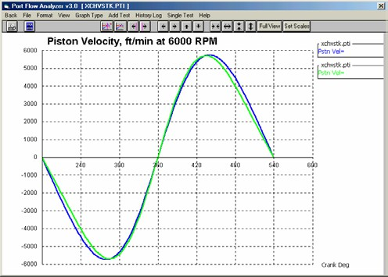
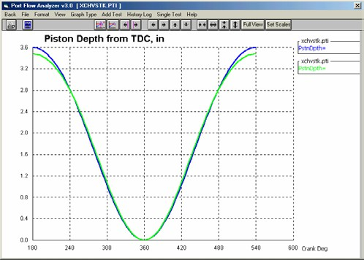
Figure A15 Engine Specs and Using Cam Files
In the Pro version, you can combine flow data with engine specs for doing engine analysis and performance projections.
Note that much more detailed analysis is available in our Engine Analyzer Pro, which can read the Port Flow Analyzer’s flow files.

Choose Yes for Use Cam File to enable Exh File and the Pick (browse) button to pick a cam file from the folder CamFiles (default) or most any folder on your computer.
Examples of New Engine Analysis Graphs (only Pseudo Flow Velocity uses flow data)

Psuedo (false) Flow Velocity in Figure A15 is the calculated INCOMPRESSIBLE velocity of the air as it passes through the valve. Some engine builders like to look at these numbers as they make changes to the head flow, cam profile, rod length, etc. HOWEVER, this is NOT the TRUE air speed, because air can compresses and expand, and its density changes with
temperature. True air speed and tuning details ARE calculated in the Engine Analyzer Pro, which gives a much more realistic idea of what is actually happening.

Running Tests Where Test Pressure is Changing
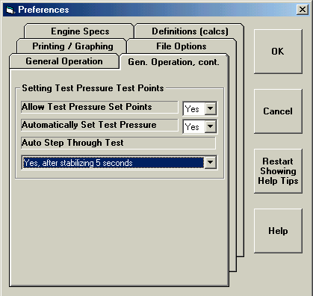
Rather that recording CFM flow data at different valve lifts, you can now choose to test a component at different Test Pressures. This is a method used for testing devices without various valve lifts, like mufflers, air cleaners, air meters, turbo components, etc.
Figure A16 Preferences Menu

Setup the Preferences menu for the appropriate options by clicking on Preferences at the top of the Main Screen. See Figure A16.

Allow Test Pressure Set Points must be set to Yes. Automatically Set Test Pressure means you want the Port Flow Analyzer to set the test pressure for each new set point. This will only work if you have a motor controller. You may want this turned off if you encounter problems with having the program setting Test Pressure automatically.

If you want the program to automatically step to the next row with a Set Test Pressure, Choose one of the “Yes” options for “Auto Step Through Test”. These also let you set the approximate amount of time to stabilize between points.

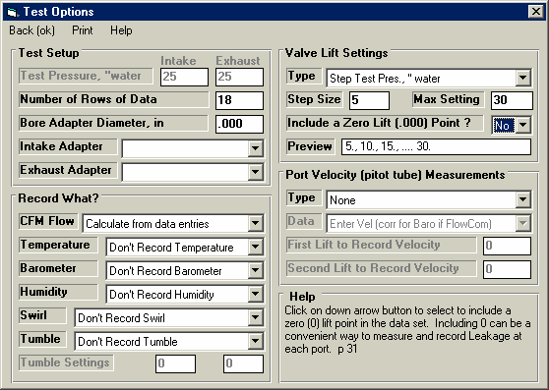
Choose the appropriate option in the Test Options menu. See Figure A17.
Figure A17 Test Options

Pick this Valve Lift Type, Step Size and Max Setting in Test Pressure increments.
Note that Test Pressure is now disabled
Now you will proceed as with any other type of test, except you (or the Port Flow Analyzer software) will set the test pressure at each different row (test point) to a different number in the “Set Pres” column. The program will record the actual test pressure (typically quite close to the Set Pres in the “Test Pres” column, and correct the CFM to what it would have been if you had obtained the exact Set Pres.

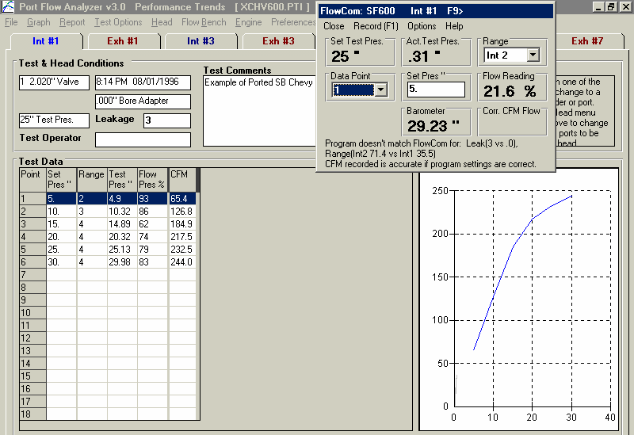
Figure A18 Main Screen Setting Test Pressure
Different Set Pres for each row instead of Valve Lift
Summary graph is now shows with Test Pressure as the X axis.
Test Pressure is now the set point instead of valve lift. This box will say “Setting x” when you have selected the program to automatically set test pressure.

If you set the Preference “Auto Step Through Test” to one of the “Yes” options, the program will automatically step to the next row, set the test pressure via the SuperFlow’s Motor Controller through the FlowCom and wait the selected amount of time.
Then the program will automatically record the data and step to the next row. For this procedure to work best, you should start at the first row. The sequence is started when you press <F1> or click on the Record menu item. When all rows with a “Set Pres” have been set and recorded, the focus should return to the first row and auto-stepping will stop.

